Teaching Masters

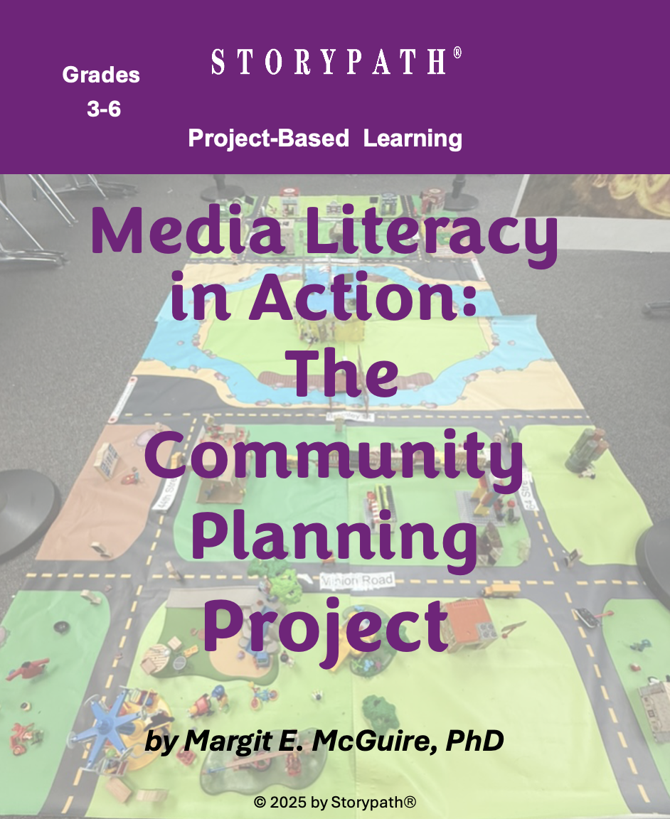
Table of Contents

- Letter of Invitation 3
- Community Planner Application 4
- Connecting with Families 5
- Layout Ideas for the Community (See Slide Set Folder)
- Homes for Our Community 6
- Businesses for Our Community 7
- Public Services for Our Community 8
- Education Facilities for Our Community 9
- Parks and Recreation for Our Community 10
- Aesthetic Features for Our Community 11
- Landscaping for Our Community 12
- Transportation for Our Community 13
- Media Controversies 14
- Letter Writing 15
- Media Announcement 16
- Poster or Flyer 17
- Invitation 18
- Self-Assessment: Social Skills 19

TM 1 Letter of Invitation

Greetings.

The Livable Community Association is seeking talented people to plan a livable community. We are seeking people who are:

- Creative
- Work well with others
- Hard working

We want to create a community that meets the needs and wants of people from many backgrounds and ages and is a great place to live.

The natural environment will be important to our livable community. We know that trees, plants, and other natural features are essential for healthy and livable communities.

The community needs the following:

- Different kinds of homes for different needs of people—single people, families, and older people who need more support in their homes.
- Places to shop and public services, such as fire and police stations, libraries, and post offices.
- Schools and other education facilities.
- Parks and recreation facilities.
- Transportation.
- Trees, plants, and other natural and aesthetic features.

Aesthetic features are the aspects that make our community beautiful such as artwork and gardens.

We hope you will apply to work on this amazing project!

Sincerely,

Livable Community Association

TM 2 COMMUNITY PLANNER APPLICATION

Name:__________________________________________ Date: ___________________________

Job qualifications:
- I can work well with others.
- I can research to find out the best ideas for creating livable communities.
- I care about the environment.
- I can read maps.
- I am creative.
- I am willing to specialize—pick your top 3 choices.
Number them 1, 2, 3, with 1 being your first choice.

In planning the livable community, I am interested in working on:

___ Homes
___ Businesses
___ Public Services
___ Education Facilities
___ Parks and Recreation
___ Landscaping Public Places Sidewalks, Plaza, Trees, & Plants (the Landscaping)
___ Aesthetic Features
___ Transportation

Draw a picture of yourself or include a photo in the box.

Explain why you want to be a community planner. Include at least two reasons.

____________________________________________________________________________________
_________________________________________________________________________________________________________________________________________________________________________

TM 3 Connecting with Families

Name:__________________________________________ Date: ___________________________

Students have started a project where they will be designing a prototype for a livable community. Your child will interview you about livable communities.

The first step in the project was to create roles for the project. Your child is a community planner specializing in:

_____________________________________________

Your child is excited about this project because ____________________________________

__________________________________________________________________________________

Questions for family interview:

- What do you like best about where you live?

- If you could make one change in our community to make it more livable, what would you change?

TM 5 Homes for Our Community

Name:__________________________________________ Date: ___________________________

Directions: Read Episode 2 Content Slide Set: Homes

In a livable community, people need lots of different kinds of homes. As community planners, you will decide the kinds of homes we will need.

Circle each kind of home you will recommend for your community. Explain why these homes are important to include.

Family homes  Apartments and condominiums | Assisted living homes  Tiny homes

Other ideas?

__________________________________________________________________________________
__________________________________________________________________________________
__________________________________________________________________________________

Why are you recommending these kinds of homes?

__________________________________________________________________________________
__________________________________________________________________________________
__________________________________________________________________________________
Where should these homes be located in our community? What is your recommendation?

__________________________________________________________________________________
__________________________________________________________________________________

Assessment: The recommendations for homes demonstrate understanding of the need for a variety of homes in a livable community.

TM 6 Businesses for Our Community

Name:__________________________________________ Date: ___________________________

Directions: Read Episode 2 Content Slide Set: Businesses

In a livable community, people need lots of different kinds of businesses. As community planners, you will decide the kinds of businesses we will need.
Circle the kinds of businesses you will recommend for your community. Explain why these businesses are important to include.

Grocery store  Drugstore  Bookstore  Gift store  Clothing store  Hair salon  Barbershop | Restaurant  Coffee shop  Bakery  Theater  Toy store  Hardware store  Pet store | Auto repair shop  Bank  Health clinic  Dentist  Veterinary clinic  Art store  Garden store

Other ideas?

____________________________________________________________________________

____________________________________________________________________________

Why are you recommending these kinds of businesses?

____________________________________________________________________________

_____________________________________________________________________________

Where should these businesses be located in our community? What is your recommendation?

____________________________________________________________________________

____________________________________________________________________________

____________________________________________________________________________

Assessment: The recommendations for businesses demonstrate understanding of the need for a variety of businesses in a livable community and why businesses should be near each other.

TM 7 Public Services for Our Community

Name:__________________________________________ Date: _______________________

Directions: Read Episode 2 Content Slide Set: Public Services

In a livable community, people need lots of different kinds of public services. As community planners, you will decide the kinds of public services we will need.

Circle the kinds of public services you will recommend for our community. Explain why these public services are important to include.

Public services also include transportation (such as buses), schools, and parks. Remember there are specialists who will decide on transportation, schools, parks, and recreation for our community.

Police station  Fire station  City hall  Post office  Library | Health clinic  Public transportation  Water and sanitation  Electricity and power

Other ideas? ___________________________________________________________________________

____________________________________________________________________________

Why are you recommending these kinds of public services?

____________________________________________________________________________

____________________________________________________________________________

____________________________________________________________________________

Where should these public services be located in our community?

_____________________________________________________________________________________
_____________________________________________________________________________________
What is your recommendation?

____________________________________________________________________________

____________________________________________________________________________

Assessment: The recommendations for public services demonstrate understanding of public services and why their location can help make a livable community.

TM 8 Education Facilities for Our Community

Name:__________________________________________ Date: _______________________

Directions: Read Episode 2 Content Slide Set: Education

In a livable community, people need schools and other educational opportunities. As community planners, you will decide the kinds of schools we will need. You also will need to decide if there will be other kinds of education in our community.

Circle the kinds of schools and education programs you will recommend for our community. Explain why these are important to include.

Elementary school  Middle school  High school | Preschool  After school programs  Other learning places

Other educational ideas? _____________________________________________________

_____________________________________________________________________________

_____________________________________________________________________________

Why are you recommending these?

_____________________________________________________________________________

_____________________________________________________________________________

_____________________________________________________________________________

Where should the schools and other educational places be located in our community? What is your recommendation?

_____________________________________________________________________________

_____________________________________________________________________________

_____________________________________________________________________________

Assessment: The recommendations for schools and other educational facilities demonstrate understanding of the need for educational opportunities in a livable community.

TM 9 Parks and Recreation for Our Community

Name:__________________________________________ Date: _______________________

Directions: Read Episode 2 Content Slide Set: Parks and Recreation

In a livable community, people need parks and recreation. As community planners, you will decide how many parks and the kinds of recreation to include. You also will need to recommend where the parks and other recreation areas should be located in the community.

Look at your Content Slide Set to get ideas for the kinds of parks you want to include. Think about who will use the parks. Explain why these are important to include.

Will there be other recreation activities such as trails for biking or gyms for sports activities?
What kind of parks should be in the community? List at least two.

_____________________________________________________________________________

_____________________________________________________________________________

Why are you recommending these?

_____________________________________________________________________________

_____________________________________________________________________________

_____________________________________________________________________________

Sometimes parks are next to schools. Is that a good idea?
Why or why not?

_____________________________________________________________________________

_____________________________________________________________________________

_____________________________________________________________________________

What other recreation facilities should we have in our community?
List at least two.

_____________________________________________________________________________

_____________________________________________________________________________

Assessment: The recommendations for parks and recreation facilities demonstrate understanding of the need for these features in a livable community. There are logical reasons for the placement of the parks and recreation facilities in the community.

TM 10 Aesthetic Features for Our Community

Name:__________________________________________ Date: _______________________

Directions: Read Episode 2 Content Slide Set: Aesthetics

In a livable community, people need beauty and special features that tell about their region, culture, and history. As community planners, you will decide what kind of aesthetic features to include. Also, you will recommend where these features should be located in the community.

Look at your Content Slide Set to get ideas for the kinds of aesthetic features you want to include. Think about who will enjoy and want to visit these places. Will these aesthetic features make people want to visit your community? Will members of your community want to see these places? For example, Seattle has the Space Needle that people like to visit. In Seattle, lots of people work for the Boeing Company, which builds airplanes and rockets. So the Space Needle is a symbol of the community.

Communities often have special features such as a town square or plaza, a welcome sign, a veterans memorial, statues, or artwork such as sculptures and outdoor murals. Use the steps below to create a special feature for the community. Be ready to explain why this feature is important to include.

Brainstorm ideas for aesthetic features that our community might have. List at least four.

______________________________________ _____________________________________

______________________________________ _____________________________________

Why are you recommending these?
_____________________________________________________________________________

_____________________________________________________________________________

Circle the best idea from your list.

Where should it be located? Why is this a good location?
_____________________________________________________________________________

_____________________________________________________________________________

Make a sketch of the aesthetic feature on a separate sheet of paper.

Assessment: The recommendation for the aesthetic feature demonstrates understanding of the need for these features in a livable community. There are logical reasons for both the feature and the placement of the feature in the community.
TM 11 Landscaping for Our Community

Name:__________________________________________ Date: _______________________

Directions: Read Episode 2 Content Slide Set: Landscaping

In a livable community, people need green spaces and gardens. Landscaping in a community is good for the environment too. Trees and plants help to clean the air and reduce noise. As community planners, you will decide where to place trees and plants in the community. You also will decide if there should be community gardens. You will work with the parks and recreation planners and the transportation planners.

Where should trees and plants be located in the community? Make a list.

_____________________________________ __________________________________

_____________________________________ __________________________________

_____________________________________ ___________________________________

Why are you recommending these places?

_____________________________________________________________________________

_____________________________________________________________________________

_____________________________________________________________________________

What kinds of trees and plants would be best for our community?

_____________________________________________________________________________

_____________________________________________________________________________

_____________________________________________________________________________

Should there be community gardens? ________ If so, where should they be placed?

_____________________________________________________________________________

_____________________________________________________________________________

Assessment: The recommendations for trees and plants and their location demonstrate understanding of the need for landscaping and green spaces in a livable community.

TM 12 Transportation for Our Community

Name:__________________________________________ Date: ________________________

Directions: Read Episode 2 Content Slide Set: Transportation

In a livable community, people need to be able to get from place to place. Remember that
we are planning a community for many different people—children, families, elderly people,
and people who go to work away from home.

There are many kinds of transportation. Different kinds of transportation can be expensive.

What are the best ideas for the livable community?

Circle what you think is best for our community.

How people get from place to place: The transportation used:
Sidewalks  Bike paths  Pathways  Roads  Train routes  Other ideas? | Walking  Bicycles  Scooters  Strollers  Wheelchairs  Cars  Buses  Trains

Why did you choose these kinds of transportation? Explain your choices.

_____________________________________________________________________________________

_____________________________________________________________________________________

_____________________________________________________________________________________

Where are the best places for the kinds of transportation you want in our community?

______________________________________________________________________________________

______________________________________________________________________________________

______________________________________________________________________________________

On a separate sheet of paper sketch out a plan for the community.

Assessment: The recommendations for transportation are reasonable, consideration is given to the range of needs of people in the community and the location of the routes demonstrates understanding for meeting the needs of the people of the community—getting to work, school, shopping, and public services.

TM 13 Media Controversies
News Flash

Scripts to be adapted for your specific Storypath community

1.
This is Hank Jones reporting from the Community News Report. It has come to my attention that the new proposal for a livable community does not have a park that is designed for young children. I decided that I should visit the park to verify this situation. Yes, indeed, the park does not have play equipment—no play equipment! How could planners make such a big mistake? The park is designed for adults. This situation could lead to serious injury. Hundreds of families are complaining. It is unfortunate that this “livable community” has ignored the children of the community.

We were told this park would be a model for other livable communities, but this is not the case. Boycott this livable community!

2.
Breaking News: The Community News Report has just learned that a big box store is planning to tear down the ______________________ [insert a logical location in the community] to build a large store and even bigger parking lot. Everyone interviewed for this report thought this was a great idea. In fact, the community planners who designed the businesses for the livable community thought this would greatly improve their community. When asked if they thought the big box store would have an impact on the small family-owned businesses in the community, they said they had no concerns.
It seems everyone is endorsing the big box store! In fact, it has been reported that 200 people are expected to come to the _______________[plaza/town center] to show their support. This is a great idea for our livable community.

Create your own!

TM 14 Letter Writing

Name:__________________________________________ Date: ___________________________

You can respond to the misinformation by writing a letter to the news reporter.

You can address the letter to the reporter or to the media editor who is the boss and who will publish it. Use the guide below to get organized.

- Identify, then make a list of the misinformation.

_________________________________________________________________________________________________________________________________________________________________________________________________________________________________________________________
- List the correct information.
_________________________________________________________________________________________________________________________________________________________________________________________________________________________________________________________
- Decide if you are going to include a photo to document the correct information.

- Tell why you are a trusted source to correct the misinformation. Tell about your role as a community planner. What did you do to create the community?
______________________________________________________________________________________________________________________________________________________________________
___________________________________________________________________________________

- Write your letter. As you write, use the writing trait called “voice.” Make sure your writing is forceful, engaging, and appropriate for the audience.

TM 15 Media Announcement

Name:__________________________________________ Date: ___________________________

You can respond to the misinformation by creating a video response.

You then can post it for your community to watch. Use the guide below to get organized.

- Identify, then make a list of the misinformation.

__________________________________________________________________________________________________________________________________________________________________________________________________________________________________________
- List the correct information.
__________________________________________________________________________________________________________________________________________________________________________________________________________________________________________
- Decide what you want to show in your video to document the correct information.

- Write a script using facts.

- Explain why the information in the media report was incorrect.
- Tell why you are a trusted source to correct the misinformation.
- Describe your role as a community planner.

- As you write your script, use the writing trait called “voice.” Make sure your script is forceful, engaging, and appropriate for the audience.

- Practice your script before you record it.

TM 16 Poster or Flyer

Name:__________________________________________ Date: ___________________________

You can respond to the misinformation by creating a poster or flyer.

- Identify, then make a list of the misinformation.

__________________________________________________________________________________________________________________________________________________________________________________________
- List the correct information.
__________________________________________________________________________________________________________________________________________________________________________________________
- Attract attention. Create a statement—a few key words or a phrase—that attracts attention. You may also want to use a drawing or photo.

- Make the poster or flyer.

  - Use a pencil to sketch where you are going to place information and visuals.
  - Use the writing trait called “voice.” Your writing or pictures should be forceful, engaging, and appropriate for the audience. Your writing should show that you care about the livable community.

TM 17 Invitation

You’re Invited!

Please join us on _____________________

We will be celebrating our livable community project!

You will learn about our community, and I will be sharing with you

_____________________________________________________________________________________

I hope you can join the community planners.

______________________________________________________________________
(Your Name)

TM 18 Self-Assessment: Social Skills
Social skills are an important part of belonging to a community. Use the chart below to keep track of how well you work with others during this unit.

Episode:_________________________________________________________________

Describe the group situation or event: __________________________________________

Group Skills | I need to work on this. | I did this some of the time. | I did this most of the time.
I was positive and respectful.
I was a good listener.
I encouraged others to participate.
I did my fair share of the work.
I worked to solve conflicts in the group.
One thing our group did well together:

____________________________________________________________________________

One thing our group needs to work on:
____________________________________________________________________________
One thing I did really well:

____________________________________________________________________________
One thing I could do better:

____________________________________________________________________________

