PORTFOLIO

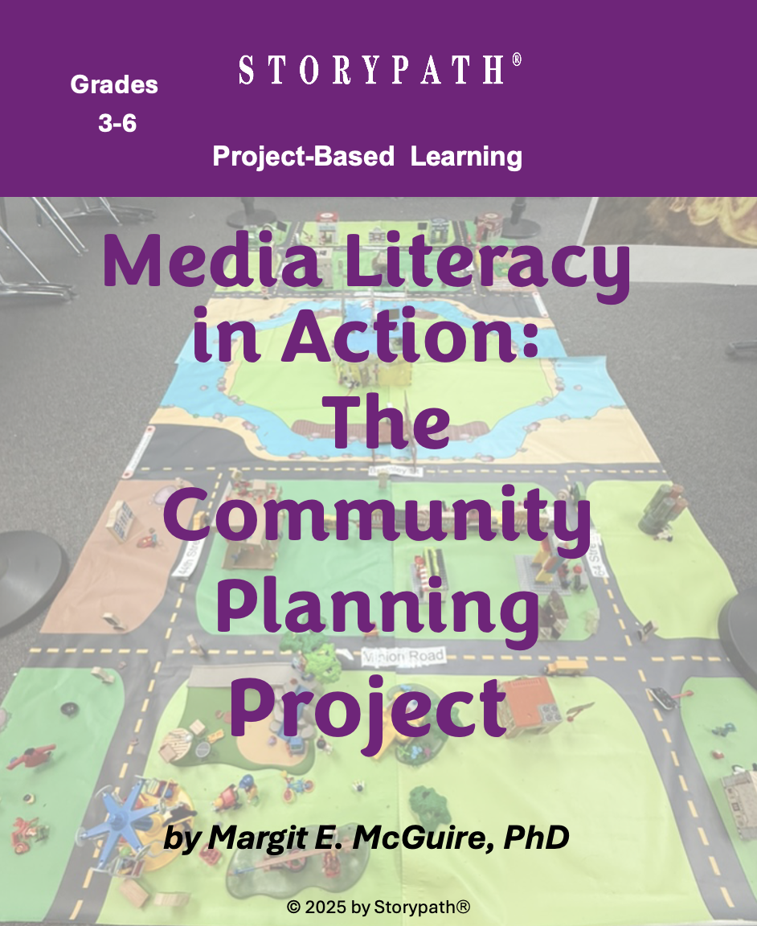

NAME___________________________________________________________________

PORTFOLIO

Understanding Media Literacy
The Community Planning Project

Episode 1

Community Planner Introductions 3

Active Listening Guide 4

Episode 3

Deliberation Strategies 5

Postcard of the Livable Community 6

Episode 4

Guide to Analyzing the News Report 7

Word Bank 8


DATE
PORTFOLIO
1

COMMUNITY PLANNER INTRODUCTIONS
Prepare an introduction of yourself using the checklist below. Keep your introduction short and to the point. Then practice your introduction with your partner. You are going to introduce yourself explaining your specialization. Remember to get into role.

Use the checklist below as you practice your introduction with your partner, and also as you listen and give feedback to them.
Checklist for preparing for an introduction:
- Am I in my role as a community planner?
- Am I starting by stating my name and my specialization?
- Am I saying the most important reason I wanted to be a community planner and am so excited to begin being one?
- Am I including information about my specialization?
- Am I speaking clearly and confidently?
- Am I making eye contact with my audience?
What feedback did you get?

Make improvements as necessary.


DATE
PORTFOLIO
2

ACTIVE LISTENING GUIDE
Introductions
Use the chart below to record the community planners’ names in their areas of specialty. After all the introductions have been given, draw lines between the boxes to show how the different groups will have to plan together to make a livable community.

Homes
Businesses
Public Services

Parks and Recreation

Education

Aesthetic Features
Landscaping

Transportation

PORTFOLIO
3

DELIBERATION STRATEGIES

When you are in a planning meeting, you want to be able to respond to the other planners’ ideas when you have something important to say.

Ask a question | - What do you mean by__________________________?  - How will this connect to (other specialization) _________________?  - Can you tell me more about _____________________________?

Add your thinking to the idea | Seek to better understand the idea
- I also think that _______________.  - To add to your idea ________________.  - Another example could be __________. | - I’m still wondering about ______________.  - I need more information ______________.  - Help me understand by saying more_____.
Take the idea in a different direction | Connect the idea to something else
- Let’s think about another idea _______________.  - I think this is a good idea, but I wonder if ________________.  - I see it differently. I think __________. | - ____________reminds me ______________.  - ____________is similar to ______________.

Coming to a decision

Having heard all the ideas, I think _________________________________________________.

I still need help understanding ____________________________________________________.

We can compromise by _________________________________________________________.

DATE
PORTFOLIO
4

POSTCARD OF THE LIVABLE COMMUNITY
A postcard can be used to briefly tell about your livable community. One side shows the photo of your livable community. The writer has space on the other side to write a message.

Write a postcard that describes your livable community to your family.
Be sure to include the following:
- accurate information and details about the community
- words from the word bank
- appropriate punctuation and grammar
- a date and your signature

Date

Dear (Write the names of the people in your family.),

Message (Describe your livable community using vivid words and details.)

Sign your name.


GUIDE TO ANALYZING THE NEWS REPORT
PORTFOLIO
5
- What is the news report about?

- Who will hear the message? How will they respond?

- Who might be harmed by this message?

- How does the message make you feel?

- Is this report fact, opinion, or untrue?

- Is the reporter trustworthy? Explain.

- How should you respond?

Assessment: The responses demonstrate understanding of media misinformation. Based on the media report, the
responses are logical, demonstrating understanding of the misinformation.


DATE
PORTFOLIO
5

WORD BANK
Keep track of the words you learn or words that interest you. Words in your word bank may come from class discussion, research, or any other source during the unit.

